Florida’s State Personnel System Employment of Individuals with Disabilities Program
The State of Florida is committed to having a diverse workforce that draws talented individuals from all segments of society, including individuals with disabilities. A diverse workforce requires recognition of the value of talent individuals with disabilities bring to the workplace. As women and men representing diverse fields, individuals with disabilities CAN and DO make valuable contributions to America’s workplaces every day.
In recognition, Florida launched initiatives in 2017 aimed at improving the quality of life, and integration of individuals with disabilities in the workforce. This includes expanding the state’s equal employment opportunity policy, section 110.112, Florida Statutes, to include affirmative action planning for individuals with disabilities.
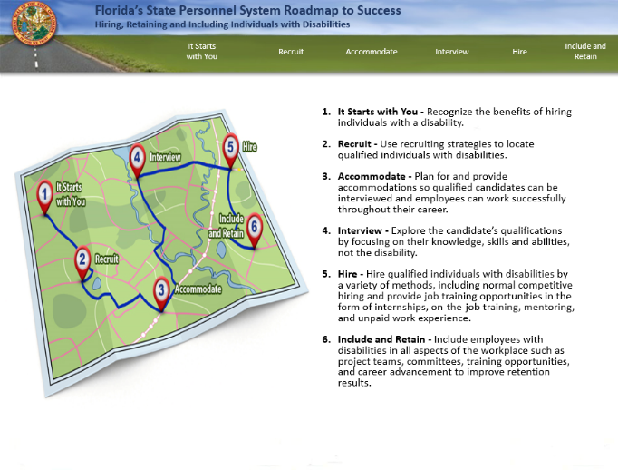
The Florida Department of Management Services – Division of Human Resource Management administers the Employment of Individuals with Disabilities (IWD) program. This program provides a comprehensive approach to enhance the inclusiveness and diversity within Florida's State Personnel System. The program provides strategies for the recruitment, hiring and retention of IWD without a legislative mandate or executive order prescribing a set number or percentage of hires. Key components of the program include on-line, interactive and self-assessment training for HR professionals and hiring managers (link: Training for Employment of Individuals with Disabilities); affirmative action planning for IWD; agency-specific plans on how to promote employment opportunities; statistical analytics; and data reporting. Since the training launched, the practitioners lauded our efforts and some agencies have incorporated the training into their learning programs.

