2021 State Employee Recognition Day
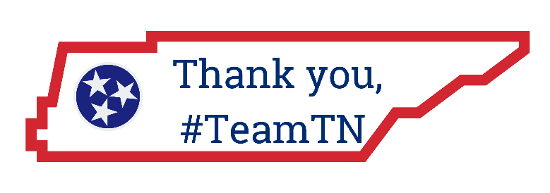

Dear [Agency/Division Name] Employees,

[ SAMPLE MESSAGE]

On behalf of the entire [Agency/Division Name] team, it is my honor to express our sincere appreciation for your work and to celebrate you today on 2021 State Employee Recognition Day.

Thank you for your contributions serving Tennessee citizens. Together, as ONE TeamTN, we are making a difference in building a better Tennessee.

Your contributions and hard work matter every day – it is my honor to take this special opportunity to express our most sincere gratitude and appreciation today.

Thank you once again for all your contributions.

Sincerely,

